Ref: GPD/SWR

27th January 2016

Dear Parent / Carer

Year 9 Consultation Evenings – Tuesday, 9th February (NAVYE) or Tuesday, 23rd February (TGOLD)

We would like to invite you to our Year 9 Consultation Evenings on Tuesday, 9th February (NAVYE) or Tuesday, 23rd February (TGOLD) 2016 from 4pm – 7pm. I hope you will be able to take advantage of this opportunity to talk about your son/daughter’s work and general progress.

To help ease the congestion, an appointment system will be in operation, and it will only be possible to see a teacher if an appointment is made. An appointment sheet is available from your child’s form tutor. Please indicate in the left hand column the names of the teachers you would like to see. This sheet should be brought back into school by your son or daughter who will be able to make appointments with the appropriate teachers. Staff will indicate in the right hand column the time of the interview.

If you feel that your son or daughter has any pastoral issues that you would like to discuss further then please arrange a separate meeting with myself or Mrs Salah (Pastoral Support Assistant).

Mrs Borg our SEN co-ordinator will also be available to speak to on the night.

Please remember to bring your appointment sheet with you to the consultation evening. A plan of the school showing the location of departments will be available on arrival.

We look forward to seeing you on the evening.

Yours sincerely,

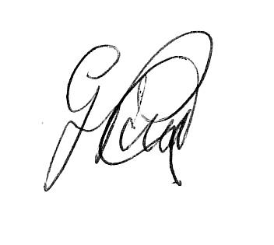

Mr Pollard
Year 9 Home School Leader
g.pollard@saddleworthschool.org

