Ref: MAN/ARE

30th November 2015

Dear Parent/Carer,

As a school we are committed to raising standards. One of the many ways we are doing this is by raising our expectations in terms of uniform and the appearance of our students. We have made this a focus since the beginning of the academic year and we have seen a marked improvement for which we thank you for your support. When we reinforced the policy around appropriate school shoes in September, a number of parents commented that they felt the next focus ought to be on girls skirt length.

After Christmas, as well as ensuring that all pupils are in appropriate school shoes, we will also ensure that all of our female students are in grey trousers or navy skirts which meet our school uniform requirements. If wearing a skirt, we request that they are A-line in style (not pleated); are navy in colour and must be of a respectable length, no more than 3"/8cm above the knee. The full details of our uniform requirements are available via the school website.

We understand that it can sometimes be difficult to find a skirt that fits well. We have been in touch with two local suppliers, Simply Schoolwear in Greenfield and Debonair in Oldham. They assure us they have a wide range of sizes and lengths to accommodate all of our students and will be happy to assist parents where needed.

As we did with shoes, we will be asking pupils who attend school without the right skirt or in a skirt that is too short to change it. If they persist in not wearing the correct uniform they will be withdrawn from lessons.

We are asking for your support in ensuring that every Saddleworth pupil is in full and appropriate uniform in January and we wanted to give you good notice regarding the requirements for skirts prior to the Christmas break.

Should you have any questions or queries or just want to clarify the contents of this letter, then please do not hesitate to contact your child’s Home School Leader or Pastoral Support Assistant.

Yours sincerely,
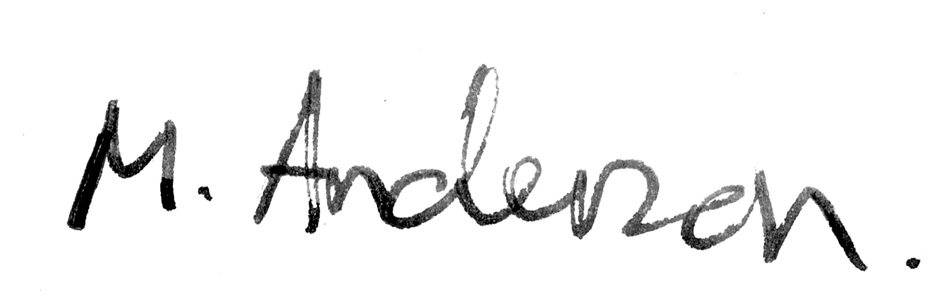
Mr M Anderson
Assistant Headteacher

