11th March 2015
Dear Parent/Carer
I am writing to you about the future of Saddleworth School.
As you are probably aware there are plans for us to deliver a new school as part of the Priority Schools Building Programme run by Government.
We are currently working in partnership on this with Oldham Council and the Education Funding Agency (EFA) which manages the project for the Department for Education (DfE).
I want to ensure you are aware that there is a consultation ongoing at the moment about the selection of the site for the new school.
The EFA completed a full appraisal of all four site options and published its findings in January. It is important that we get a broad and full range of opinions before a paper goes to Oldham Council’s Cabinet on 30th March seeking a final decision on the site of the new school.
As you will see from the attached statement, Governors at Saddleworth are unanimous in their support of the Diggle site.
You can submit your consultation feedback by completing an online form at: www.oldham.gov.uk/new_saddleworth_school You can also view copies of the EFA Feasibility Study – and a set of Frequently Asked Questions – at that webpage. Hard copies of the EFA study are available to view in Saddleworth, Lees and Oldham libraries on request. People can also submit their views in writing and send them to:
Saddleworth School Consultation
Directorate of Economy and Skills
Oldham Council
Level 3 Civic Centre
West Street
Oldham
OL1 1UH
Please note that final submissions to this consultation must be received by no later than 5pm on Wednesday, 18th March at 5pm.
Yours sincerely,
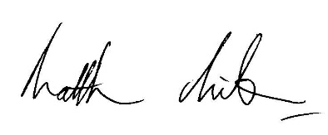
Matthew Milburn
Headteacher

