September 2015

Dear Parent/Carer,

Over the past few days we have had reports from some students who say that they have seen a suspicious looking man on the way to or from school who they believe has been following them. On Tuesday 15th September two of or pupils reported seeing a man who was engaged in an indecent act. These incidents are reported as having taken place near Carr Lane in Greenfield.

We don’t want to cause undue alarm. However we wanted to inform parents so that you are able to take reasonable steps to safeguard your child on the way to and from school. We have also spoken to students through assemblies and form time and urged them to be cautious. We would advise that if students walk travel to and from school in groups, if they are not already doing so.

All incidents have been reported to the police who have assured us that they are investigating this matter with the utmost urgency.

Yours sincerely,

Mr M Anderson
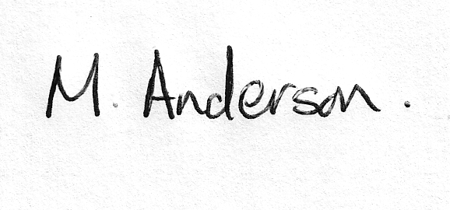
Assistant Headteacher

