Ref: LTT/EGE

22nd November 2013

Dear Parent/Carer

I am pleased to inform you that your child has a place on the ISTA trip to London in March. I am currently completing the risk assessments and organisational elements that need to be in place and will be in touch shortly with information about how to make payments (the school uses online payments to save money and time and to reduce the risk of children losing cheques).
In the meantime, could you please note the following:-

- Consent forms need to be completed and handed back to Miss Trickett asap.

- There are two payments which are in two instalments of £100 and £150, the first of which is due by November 26th in order to secure the place.

- We will hold an information evening for parents in February but in the meantime, please send any questions or queries to Miss Trickett at l.trickett@saddleworth.org and she’ll do her best to answer them. There are some photographs and videos of other trips organised by ISTA on their web site in the Media section which might whet your child’s appetite. These can be found on www.ista.co.uk

We are pleased and excited to be taking your children on this exciting experience and hope they will have a wonderful time.

Yours sincerely
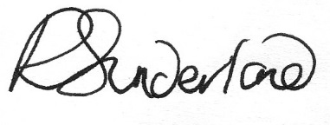
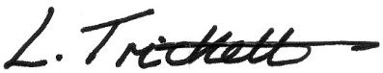

Miss Sunderland and Miss Trickett.

