Ref: JCK/ARE

7th October 2013

Dear Parent/Carer

STUDENT PHOTOGRAPHS

The special needs department at Saddleworth School is seeking your permission for your child’s photo to be used for a video on our school website.

If, for any reason, you do not wish your child to be included, then please complete and return the reply slip at the bottom of this letter to Miss Cook in the Learning Base before Friday, 18th October 2013.

Yours sincerely

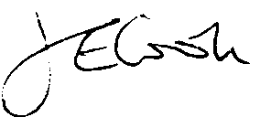

Miss J Cook
SENCO

THIS REPLY SLIP IS ONLY TO BE RETURNED IF CONSENT IS REFUSED

STUDENT PHOTOGRAPHS – REFUSAL OF CONSENT

I do not wish my son/daughter’s photo to be used.

Name of student ___________________________________Form: ____________________

Signed: ______________________________Parent/Carer) Date: ____________________

(Please return to Miss Cook in the Learning Base)

