September 2015

Dear Parent/Carer

Your investment, their future

Saddleworth School is a thriving and ambitious school. We endeavour to provide the very best learning opportunities for our students challenging them to ‘Aim High’ and to reach their full potential. We continually strive to offer a balanced, exciting and high quality education which will equip your child and all of our students for the challenges of the 21st Century.

Whilst the government provides us with sufficient funding for the basic curriculum we offer it does not match our ambitions and we want to go further. As the cuts in public services bite deeper our capacity to provide the very best for our students becomes more challenging. The effect of the cuts has been to limit our capacity to provide the curriculum and enrichment opportunities that brings learning to life and so often leaves a lasting and positive impression on our pupils’ futures. For example, we are currently paying back for a school mini bus that enables us to take pupils to fixtures, performances and lectures off site. The mini bus costs £6,000 a year for four years and with the help of parental contributions we can keep the vehicle on the road.

The cuts also mean we are unable to replace some of the equipment, furniture and IT we use, some of which are now beyond their ‘shelf-life’ and need replacing. When we move to a new building we will need to take most of these items with us as the funding covers the building and grounds only.

For the continued development of the school we ask parents to consider making a one-off or regular donation to enable us to provide the very best education for our pupils. We understand families are under financial pressures too, but please consider this to be a small investment towards your child’s future.

If you are able to assist please complete the attached form and return to school.

Yours sincerely
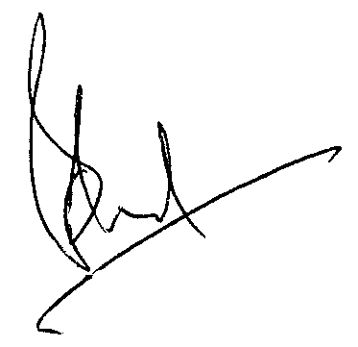

Mr Brian Lord
Chair of Governors

