Dear Parent / Carer

I just wanted to say a massive thank you to everyone that supported in any way our MacMillan Coffee morning. We raised an amazing: -

£1,062.04

which off cupcakes ranging from 10p to £1 really is staggering. Apologies Miss Craddock as I am sure we didn't quite fulfil your Health Schools Gold Award on Friday.

I was truly overwhelmed by the way everyone got involved, the kindness of everyone that donated and how much cake we received. I would love to thank everyone who brought cakes in or bought a cake on the day to make it the success it was.

There are as always a few special mentions to individuals that helped make it possible that I would like to make to:

Mrs Speakes who made the beautiful cake that we raffled. She also made the draw for us in the afternoon and presented the winner Charlotte Scott, year 8 with her prize.

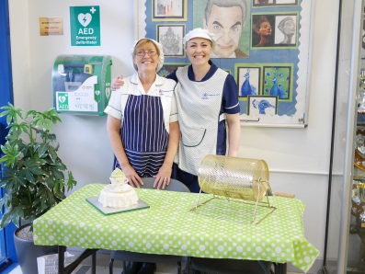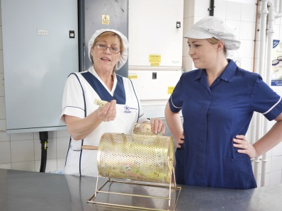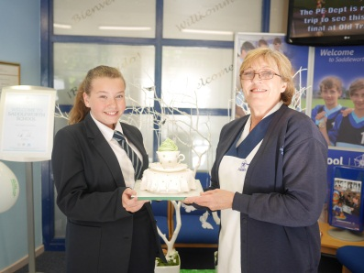

Mr Watling and the team in setting up the tables.

Mrs Noyes who decorated reception for me and sold the butterflies to allow those that wished to share their thoughts for loved ones. I know this brought a tear to many eyes but I thought it was an important way to reflect the true meaning of the day and allow the students to appreciate how the money they raised would help. I was touched by the maturity of our students, their sensitivity and compassion. I will be incorporating the butterflies and their messages into a display to mark the event, how much we raised and in tribute to everyone that has been affected.

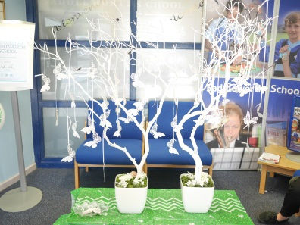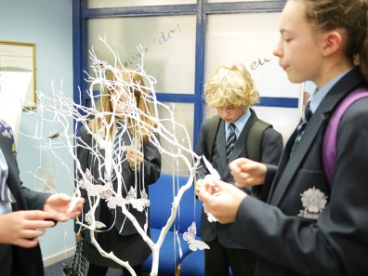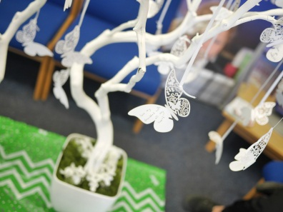

Miss Cook for inspiring the Year 8 in their Great British Bake off Apprenticeship style that took over the sports hall at lunch and raised nearly £400 alone. There were really too many to name but the effort they displayed with the cakes they had baked, the planning of their stalls with decoration and price lists, those that had got a fundraising kit and all the official table clothes and balloons. . . . It was amazing. They were also greatly supported by their form tutors, giving up their free time to support them. With only 60p in between the winning and second place form it really was competitive. I will let Miss Cook announce her winners in assembly as I know it is much anticipated.

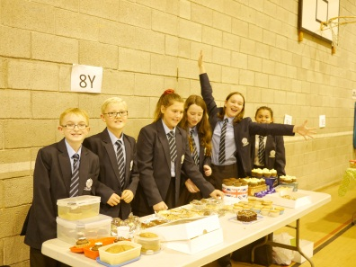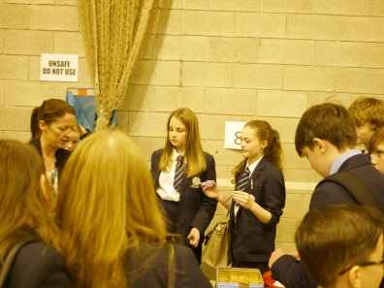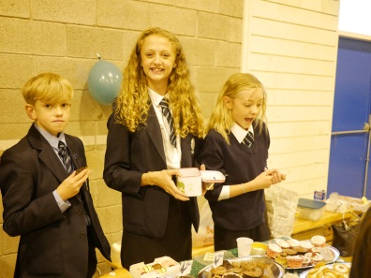

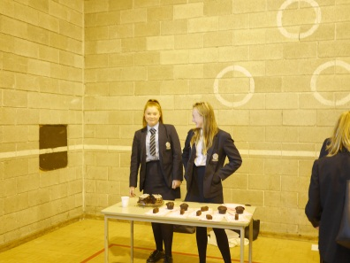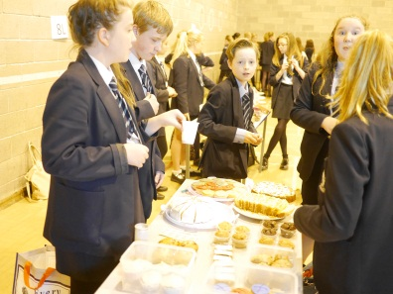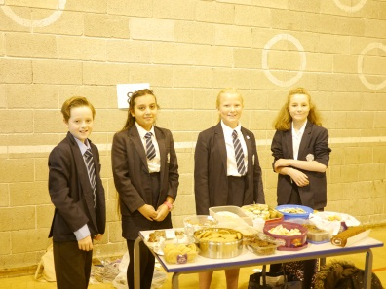

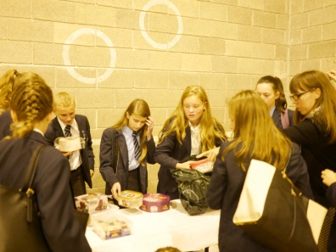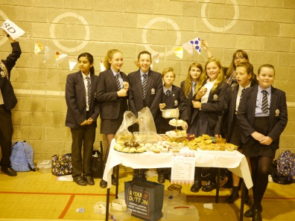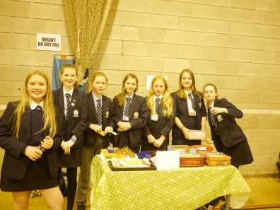

Mr Spurr and Mrs Byrne, our Governors that came in to support the day and bought a piece of cake from every year 8 form.

Mrs Byron who had her office taken over by cakes.

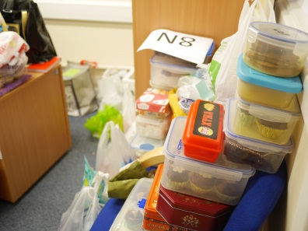

Mrs Briggs that had our office taken over by everything. She did ask at one point if I was moving in!

Sophie McGregor who baked and sold cakes in the learning base to contribute to 8T's total.

Mrs Hegarty’s form 7L offered to bake cakes and Poppy Stafford, Faith Schofield, Edward Warrington, Jayme Keeley who managed the stall in the year 7 common room on their behalf raising just over £75 towards our grand total.

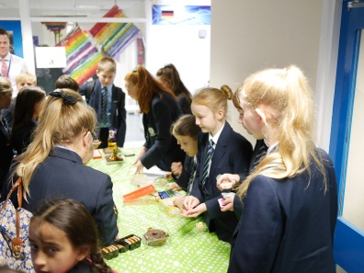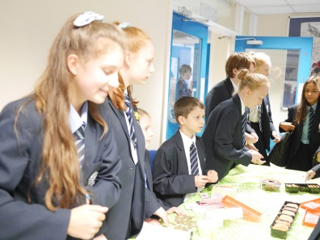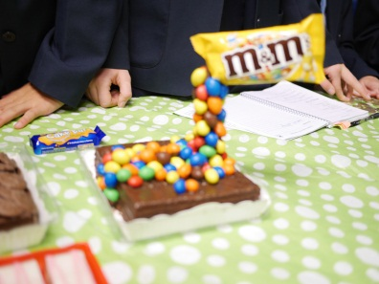

Lucy George and Sophie Glynn that offered to volunteer and supported the year 7's in their sales.

The office for counting all the money.

George Mitchell in Year 9 and his family that made a very generous personal donation of £75 to the great cause.

And lastly, but by no means least to the year 10 girls that helped immensely throughout the day and Mr Simkins for getting them on board (I called them my charity ambassadors as they were amazing) They helped by setting it all up, selling the cakes at break, preparing the cakes for lunch, selling the cakes at lunch, helping to count the money and selling again the cakes we had left after school. . .

Roshni P, Katie A, Katie B, Grace M, Maisie J, Emily R, Daisy S, Zoe P, Paige C, Annabelle W,
Eve D, Niamh B.

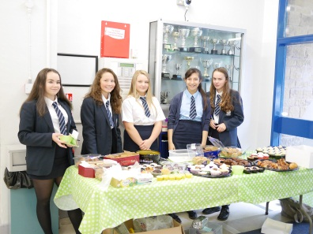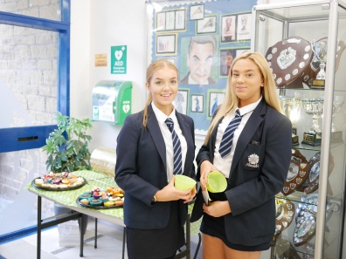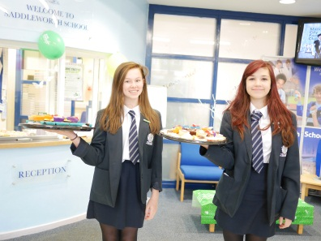

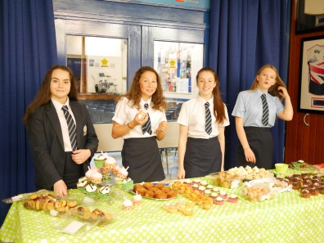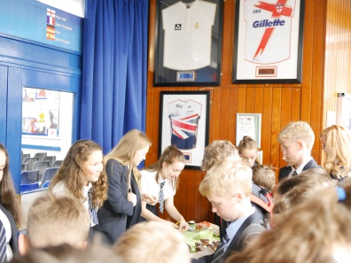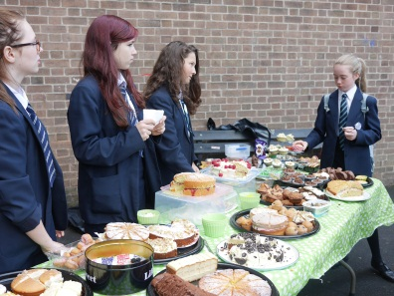

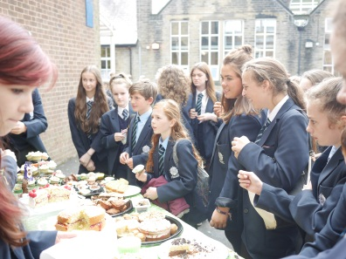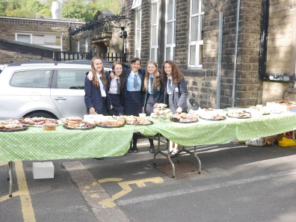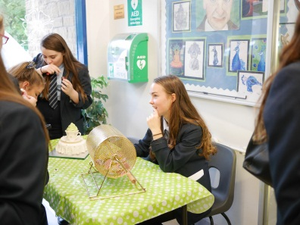

They really did run the day and make it so easy. Mr Barker they have my vote for your Year 10 Ambassador programme.

It really does show why Saddleworth is such an amazing place and how wonderful our students are when they are asked to get involved

Please will you pass on my thanks to everyone named in person, give an extra little thanks to congratulate them for going above and beyond.

Thank you again.

Claire McMurdo
Assistant Headteacher
c.mcmurdo@saddleworthschool.org

PS. If you kindly sent cakes into school in Tupperware then it is likely I still have it as many items have not been collected. They are safely stored in my office on the Science floor so please remind your children to collect on your behalf.

