RSD/SMS

24th February 2014

Dear Parent/ Carer

Re: Sex and Relationship education

On the 17th March students will be timetabled to watch a theatre production about sexual exploitation aimed at Year 9 students. There will be lesson activities to prepare students for this during PSHE lessons before the production date. The production has previously been viewed by Mrs Wolfenden and Miss Trickett and is thought to deal with a difficult topic sensitively. During April and May your son/ daughter will also be having a series of SRE lessons led by teachers in school and a session delivered by the school nurse. The lessons are designed to raise awareness about caring relationships, the law regarding sex, STI’s, contraception and access to help and support. The school nurses are experienced in delivering the sessions to year 9 students and work in a range of schools in Oldham.

The purpose of Sex and Relationship Education (SRE) is to provide knowledge and understanding so that pupils develop into adults who hold positive values, have knowledge of the arguments for delaying sexual activity and understand the importance of protected sex. It should develop attitudes which will help pupils to form relationships in a responsible and healthy manner.

If young people can start their transition into adulthood with good information and the confidence and knowledge to understand what is happening to them, they will hopefully grow into confident and healthy adults able to make positive choices. We hope that the provision in school will support the discussions you have with your child at home.

Parents can withdraw their children from all or part of sex education that does not form part of the statutory National Curriculum. If you wish to withdraw your child from all or part of the school’s sex education programme please contact me in writing before 5th March 2014.

Yours sincerely

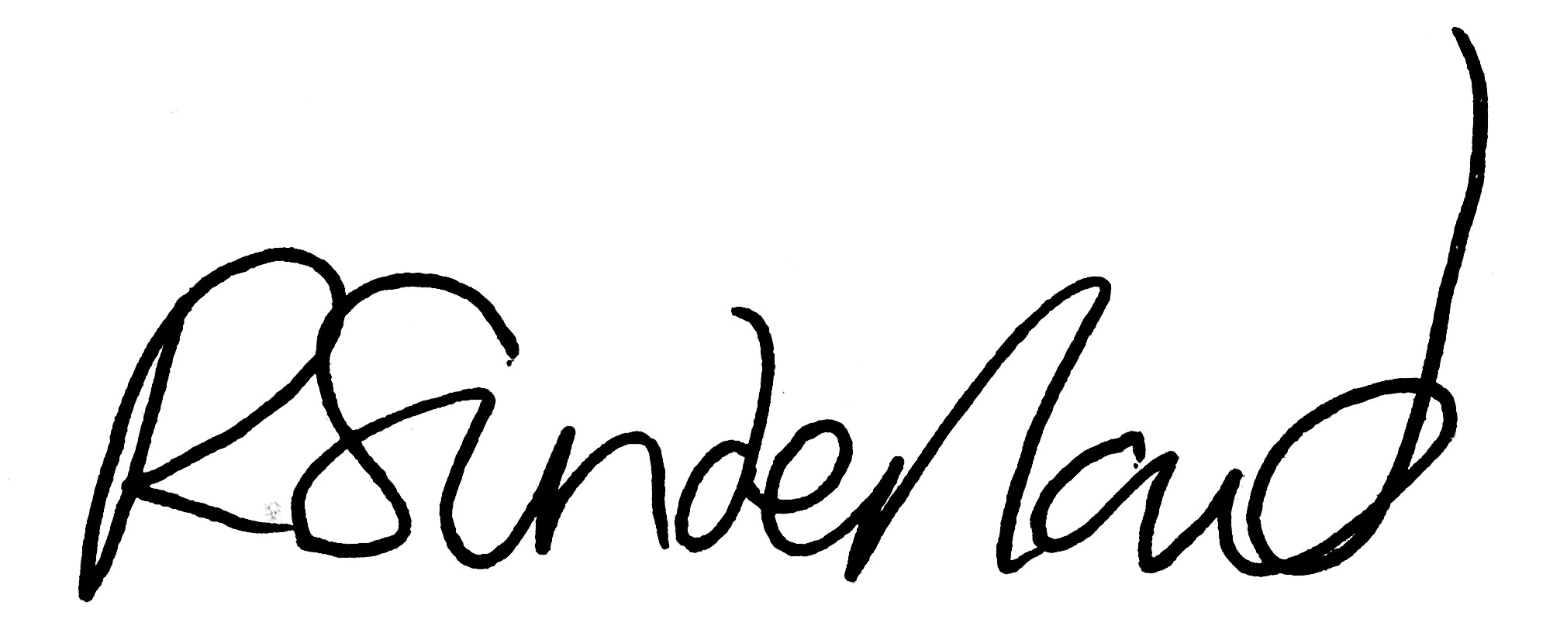

Miss Rachael Sunderland

