February 2015

Dear Parent / Carer

At this mid-point in the academic year, it is timely to remind and reassure parents/carers regarding our expectations in and around school. We have made no secret of the standards that we believe to be vital in enabling Saddleworth students to make the most of school. Occasionally, some children choose to push the boundaries in terms of behaviour, work ethic and standards of appearance; it is our joint responsibility at such times to remain resolute in maintaining the high standards that have contributed hugely to the success of the students who have progressed through Saddleworth over the years.

This term has undoubtedly posed challenges for everyone in terms of the extreme weather conditions, a result of which was that we relaxed some elements of the school uniform. It made sense for students to wear boots, scarves, hats and gloves. Given the conditions, I was heartened by the efforts made by the vast majority of students to get to school, enabling productive learning to take place.

Hopefully, we are over the worst of conditions and consequently, we should now see a return to full and smart uniform including traditional, sensible black shoes. With effect from Monday, 23rd February, there will be a refocus on standards, including standards of dress. Students will be addressed in assemblies and staff will be advised to take a consistent approach in addressing any student’s reluctance to fulfil expectations. A copy of the school uniform can be found in the Student Planner (page 17).

I would draw your attention to the following in particular:
- Plain black shoes – not trainers and no white or coloured markings.
- Some students tend to feel the cold more than others. Whilst outdoor coats should not be worn in the school building, students may wear a plain navy blue pullover or cardigan under their blazer; hoodies are not acceptable. Any scarves and outdoor coats to be removed on entry to the school

I would also like to take this opportunity to remind you that mobile phones and portable music players should not be seen in school. If seen they will be confiscated. A parent will then have to collect the device or, after five school days, it can be returned to the student. For clarity – any mobile device brought into school, including phones, must be switched off and put out of sight for the duration of the school day. Any parent or carer wishing to contact their child in an emergency can do so by telephoning the school.

Punctuality and readiness for work, although essentially a strength of the school, do need occasional reinforcement. Students should be settled in class by 8.45am prompt and should be equipped for the day. As a minimum, students should present a planner, a pen (pencil and ruler) and any specialist equipment for the day

We pride ourselves on providing the best opportunities for the students in our care; central to this remains an insistence on high standards. We also pride ourselves on positive relationships with children and their parents. By applying a consistent approach, with home and school working together, I sincerely believe that we strengthen this relationship.

I thank you for your continued support for the school and your child. Be assured that everything we do is with your child’s best interests at heart.

Yours sincerely
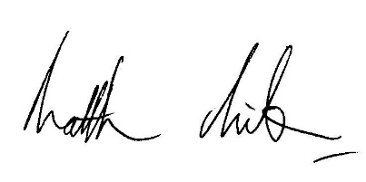
Matthew Milburn
Headteacher

