17th June 2015

Dear Parent / Carer,

Proposed Saddleworth School, Diggle – Public Consultation

Many thanks to those parents who have taken the time to participate in the consultation exercise that has been set up by Interserve regarding the new building. Thanks also to those who have attended the public exhibitions that were staged to give people the chance to look at the plans for the school and the highways works that are being proposed.

If you have not yet had the time to share your thoughts then you have until 5pm on Tuesday, 23rd June to do so. I would urge as many of you as possible, including students, to look at the plans online (www.newsaddleworthschool.co.uk) and make your views known. Be aware that this consultation focuses on the details of the school design and development, not the location of the school. It is also a genuine consultation; all feedback received is being reviewed individually and where possible changes are being incorporated into the design. The more feedback that is received, the more effective the consultation will be.

I am genuinely excited about the new school being built. I believe that the architects have successfully translated the schools vision with regards to the internal layout of the school and I hope very much that in years to come it becomes a building that embodies the value we place in young people and their learning.

Yours sincerely,
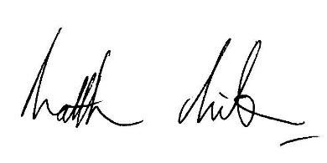

Matthew Milburn
Headteacher

