Dear Parent / Carer,

A big thank you to everyone that supported the day. I am proud to announce…….


It really was a great day with lots going on. As always there are a few special thank you’s that need to be made. To Mr Pheby’s Skillforce class for organising the opportunity to throw wet sponges at the staff and to Mr Pheby and Mr Simkins for volunteering to be the targets.

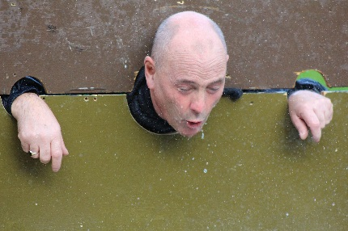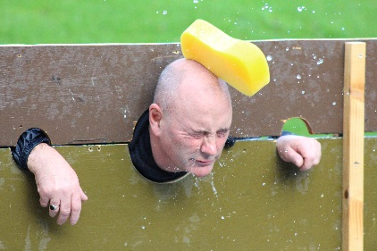

To the staff that kindly offered to have their legs waxed (Mr Dinsdale, Mr Cree, Mr Lucas and Mr Meadowcroft), Miss Cotton and Miss Clements for acting as the beauticians and Mr Wadsorth for his amazing job as the compere for the event. I won’t pass comment on the difference in pain thresholds between Mr Meadowcroft and Mr Cree (must be the training from your earlier training days Mr Meadowcroft).
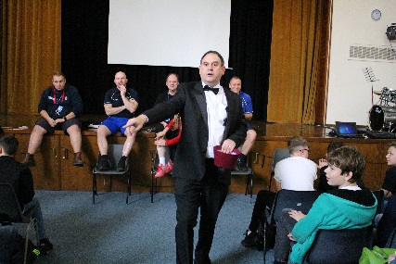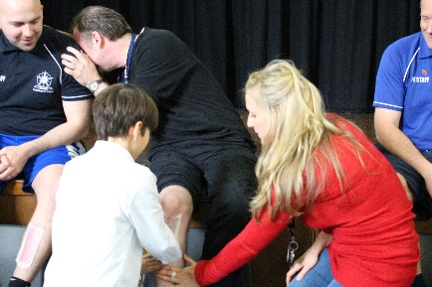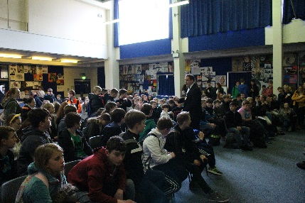
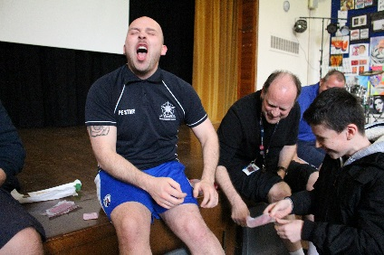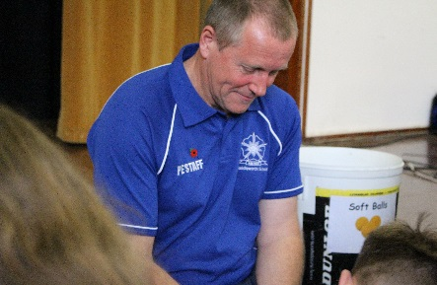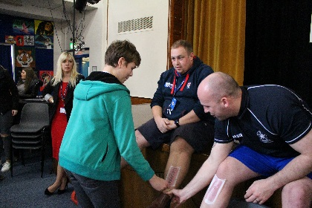

To the staff that went the extra mile and sacrificed their ‘Dress Friday’ for onesies. The canteen staff that beautifully decorated biscuits in keeping with the day. Mr Nazir’s form who went above and beyond.
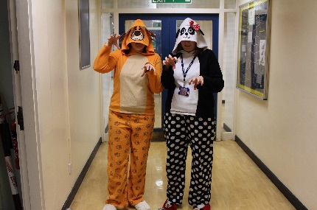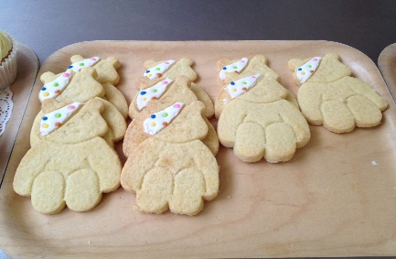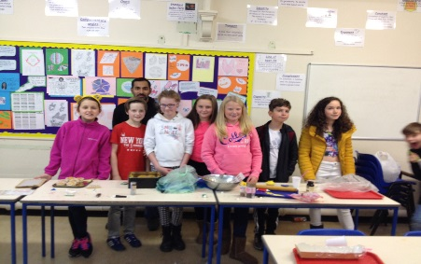

And to these two that just made me smile. . . as they randomly put on their ears!!!
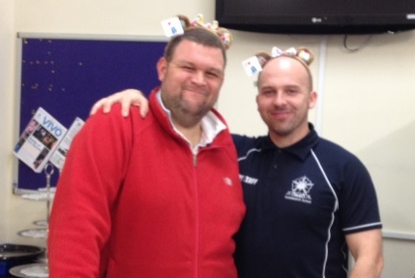
To individuals that held raffles, cake sales and sponsored silences. . . . there really are too many to name individually but helped make it a great day (I have certificates to give out in assemblies to you all).

The office staff who kindly collected and counted all the money to get our final amount.

Thank you all for your support and for getting involved. It really will make a difference to the lives of less fortunate children.

Thank you for your continued support.
Mrs McMurdo
Assistant Headteacher. Community and Operations

