Ref: MMN/ARE

23rd March 2016

Dear Parent/Carer

I am writing to tell you about a possible change to education in our area.

Schools across the Saddleworth and Lees district already work together closely for the benefit of children, young people and families. This happens on an informal basis and is very effective for all of us. It brings several benefits, such as sharing best practice, making financial savings, learning from each other’s strengths, taking a co-ordinated approach to local education and supporting children through their journey from primary school to secondary school and out into the wider world.

A number of schools in Saddleworth and Lees have now decided to look into the possibility of joining together more formally. It is important to stress that, at this stage, we don’t know what this arrangement could eventually look like. However, we have begun the process of exploring all the different options for a formal partnership.

As you know, the education landscape has changed significantly over recent years. It continues to do so, and each school has agreed that it should examine future ways of working together. The aim is to find the best way of ensuring our schools are as strong as possible for many years to come. We want to achieve the very best for children, young people and families by learning and working with each other and for each other.

You may have seen an announcement over the last few days that central government intends all schools to become academies (which means they are not maintained by the local authority). Clearly this is a consideration when we look into potential partnerships, but we were already committed to this piece of work before the government’s announcement. Our school governors voted in favour of exploring the different options at their most recent meeting.

The schools which are looking into a formal partnership will now appoint an independent expert to lead on the project. This role is about to be advertised and the cost of the appointment will be shared. Our consultant will spend the next 12 months examining all the possible ways forward so that each school can reach an informed decision about how to proceed. This may involve a consultation process for parents, carers and the wider community.

We don’t expect any final decisions to be made until mid-2017 at the earliest, after the consultant has reported back their findings and each governing body has had time to fully reflect. I can assure you that, if a change does take place, it will not affect the day-to-day running of Saddleworth School. The biggest differences would be ‘behind the scenes’ as each school in the partnership joined forces in strengthening education for local children.
We all hugely value our unique qualities and our own identities – the things that make our schools truly special. If a formal partnership went ahead, this would not be compromised and we would very much continue to be Saddleworth School, working proudly with our local community to help children fulfil their potential.

I will, of course, keep you updated with this important process.

Yours sincerely,
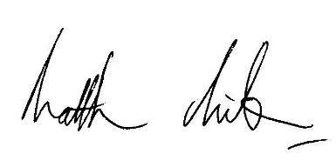
Matthew Milburn
Headteacher

