September 2016

Dear Parent / Carer

Did you know … just registering your child for Free School Meals means that the school may receive extra funding? Register now to make sure we don’t miss out.

The Government is giving money to schools to help children from lower income families do their very best. This funding is called a ‘Pupil Premium’.

For every child registered Saddleworth School can receive £935.00.
The money would be used towards improving the learning environment and enhancing your child’s learning experience.

Eligibility Criteria
You can register your child for Free School Meals if you get any of these benefits:

- Income Support
- Income-based Jobseeker’s Allowance
- Income-related Employment and Support Allowance
- Support under Pare VI of the Immigration and Asylum Act 1999
- The Guarantee element of State Pension Credit
- Child Tax Credit, provided they are not entitled to Working tax Credit and have an annual income (as assessed by HM Revenue and customs) that does not exceed the current year’s level
- Working Tax Credit, during the four week period immediately after your employment finished, or after you start to work less than 16 hours per week.

How does it work?
- First check if you qualify – see the Eligibility Criteria above. Complete the attached application form and return it to Oldham Council. All forms will be treated in strict confidence. No one will know you have registered and it will not affect any other benefits you are claiming.

2. If you want your child to have a free, healthy meal at lunchtime that’s great – they will get the free meal (saving you more than £350 a year) and the school gets £935.00. We also operate a Cashless Catering system in school which means your child’s free meal allowance is automatically added daily to their account ready for when they go to eat at lunchtime.

4. If you don’t want your child to have the school meal they can continue as normal – as long as you qualify and are registered, the school still gets £935.00

If you are unsure about applying please contact Oldham Council on 0161 770 6688.

Yours sincerely
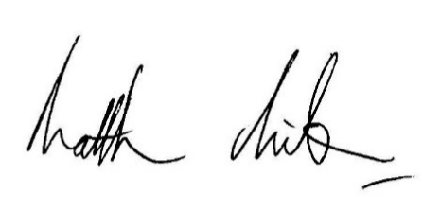

Mr M Milburn
Headteacher

