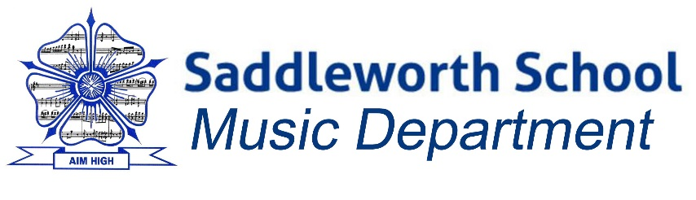
Proudly presents…
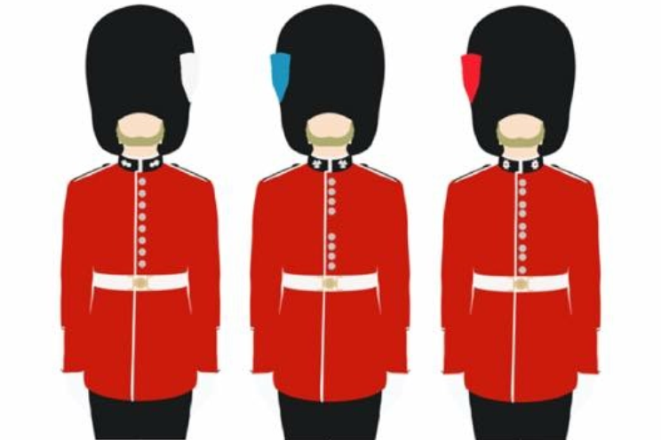

The Guards Brass Ensemble
Friday 29th April 2016
The Guards Brass Ensemble will be performing LIVE at Saddleworth School
THIS Friday 29th April 2016
This is the first time the ensemble have performed in the North of England and a fabulous opportunity to hear this phenomenal group of musicians in a LIVE capacity – a real once in a lifetime opportunity!!!
- 11:00am - ALL Saddleworth School instrumental students are invited to attend a demonstration / recital performance in the Main Hall.
- 3:00pm - Student showcase and concert performance by the Guards Brass Ensemble - again ALL instrumentalists at the school to attend this concert performance.

- ADULT TICKETS ARE AVAILABLE FOR THIS AFTERNOON PERFORMANCE (3.00pm – approx. 4:30pm)
- Tickets are available by emailing music@saddleworthschool.org – flat rate of £5.00 per adult ticket (ALL proceeds to Saddleworth School Music Department Fund). Once tickets are reserved they can be paid for and collected on door at the school reception – the performance will start at 3:00pm prompt.

