Safeguarding Policy | 
Contents:

1 | Rationale
2 | Purpose of the Policy
3 | Roles and Responsibilities
4 | What school staff should look out for
5 | Child Protection and Safeguarding Procedures
6 | What to do if you have a safeguarding concern.
7 | Abuse by children and young people
8 | Record Keeping
9 | Opportunities to teach safeguarding
10 | Training and support
11 | Allegations Involving School Staff/Volunteers
12 | Safer Working Practices
Appendix 1 | Safeguarding Referral form
Appendix 2 | Contact details for referrals.
Appendix 3 | Appendix 2 – Extracts from Department Of Education publication ‘what to do if you’re worried a child is being abused: advice for practitioners’ March 2015
Appendix 4 | Further information on Female Genital Mutilation
Appendix 5 | Further information on Child Sexual Exploitation

1. Rationale:

The governors and staff at Saddleworth School consider the safeguarding of the students in our care to be a major priority and responsibility. We are a school who seeks to create an atmosphere where young people feel secure, are encouraged to talk and are listened to.

Safeguarding is defined as protecting children from maltreatment, preventing impairment of health and/or development, ensuring that children grow up in the provision of safe and effective care and taking action to enable all children to have the best life chances.

2. Purpose of the policy:

Rationale
- To raise the awareness of all school staff of the importance of safeguarding students and of their responsibilities for identifying and reporting actual or suspected abuse.
- To ensure students and parents are aware that the school takes safeguarding seriously and will follow the appropriate procedures for identifying and reporting abuse and for dealing with allegations against staff
- To promote effective liaison with other agencies to work together for the protection of all pupils.
- To support pupils’ development in ways which will foster security, confidence and independence.
- To integrate a safeguarding curriculum within the existing curriculum allowing for continuity and progress through all key stages.

3. Roles and Responsibilities:

Child Protection and Safeguarding Roles and Responsibilities:

Overall responsibility for Child Protection/Safeguarding – Mr M Milburn (Headteacher)

Whole school Designated Safeguarding Lead – Mr M Anderson (Assistant Headteacher)

- To manage the overarching systems that underpin child protection and safeguarding.
- To maintain an overview of all ongoing child protection and safeguarding concerns across the school.
- To provide support and guidance to the Designated Year Group Safeguarding leads.
- To quality assure the child protection and safeguarding process.
- To liaise with the Head teacher to inform him/her of child protection and safeguarding issues.
- To ensure the school’s policies are reviewed annually and communicated to all staff and parents.
- To ensure all school staff receive regular and appropriate child protection training (including all new staff as part of their induction.)

Deputy Designated Safeguarding Lead – Mrs J Leach-Ravey (Pupil Support Co-ordinator)

- To monitor ongoing safeguarding concerns; taking appropriate action when required.
- To provide support and guidance to safeguarding team and other staff as required.
- To monitor record keeping to ensure it is accurate and up to date across all year groups.
- To support the Designated Safeguarding Lead in quality assuring the safeguarding process.

Designated Year Group Safeguarding Leads – Home School Leaders

- To maintain on overview of their year group ensuring that potential safeguarding issues are identified early.
- To monitor ongoing safeguarding concerns; taking appropriate action where required.
- To make referrals to external agencies when required e.g. Early Help Team.
- To liaise with parents as required.
- To ensure safeguarding records for their year group are accurate and up to date.
- To regularly update Designated Safeguarding Lead and Deputy Designated Safeguarding Lead of safeguarding concerns in their year group.

Pastoral Support Assistants:

- To support the Home School Leader in maintaining overview of their year group ensuring that potential safeguarding issues are identified
- To support the Home School Leader to monitor ongoing safeguarding concerns; taking appropriate action when required.
- To make referrals to external agencies when required.
- To liaise with parents as required.
- To be responsible for keeping safeguarding records their year group which are accurate and up to date.
- Where necessary support Designated Safeguarding Lead; Deputy Designated Safeguarding Lead and Designated Year group Safeguarding Leads with safeguarding concerns.

All school staff

- Everyone who comes into contact with children and their families has a role to play in safeguarding children. School staff are particularly important as they are in a position to identify concerns early and provide help for children, to prevent concerns from escalating.

- To provide a safe environment in which students can learn.

- To identify children who may be in need of extra help or who are suffering, or are likely to suffer, significant harm. All staff then have a responsibility to take appropriate action, working with other services as needed.

- To pass on any child protection concerns to the appropriate Designated Year group Safeguarding Lead or Pastoral Assistant. If the appropriate Designated Year group Safeguarding Lead or PSA is unavailable any member of the Child Protection and Safeguarding team outlined in this policy should be approached. This initial concern should be done verbally, as soon as possible after the concern arises, but certainly on the same day. This should then be followed up by a written referral (see Appendix 1).

- If there is not a member of the safeguarding team available; all staff can make referrals of suspected abuse to the appropriate Local Authority Children’s Social Care or police if they feel this is necessary. (Contact details of relevant agencies can be found in Appendix 2)

- To alert the Year group Safeguarding Leads if a student goes missing from education.

- To alert the Year group Safeguarding Leads if a student internally truants / goes missing during the school day.

Governors

The Governing Body has overall responsibility for ensuring that there are sufficient measures in place to safeguard the children in their establishment.

In particular the Governing Body must ensure that the following are in place:

- Child protection policy and procedures
- Safe recruitment procedures
- Appointment of a Designated Safeguarding Lead who is a senior member of the school leadership team
- Relevant safeguarding children training for school staff is attended
- Safe management of allegations
- Deficiencies or weaknesses in safeguarding arrangements are remedied without delay
- A member of the Governing Body (usually the Chair) is nominated to liaise with the local authority and/or partner agencies on issues of child protection and in the event of allegations of abuse made against the Headteacher
- Safeguarding policies and procedures are reviewed annually

4. What school staff should look out for

Key signs of abuse

- All school staff member should be aware of the signs of abuse and neglect so that they are able to identify cases of children who may be in need of help or protection.

- All staff should refer to the signs of abuse outlined in the Department Of Education publication ‘what to do if you’re worried a child is being abused: advice for practitioners’ March 2015 - see Appendix 3 for key extracts. In addition there is good advice provided on the NSPCC website.

Types of abuse

Extract from Keeping Children Safe in Education – Statutory guidance for schools and colleges – July 2015
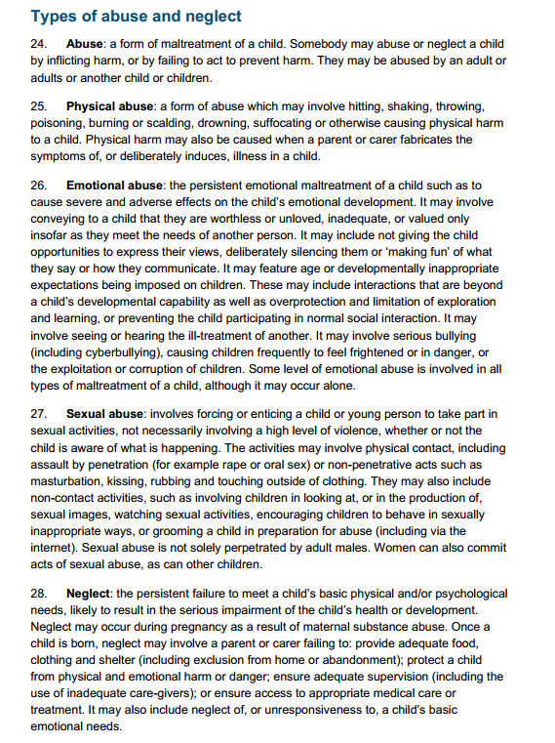

Specific safeguarding issues:

In addition to being vigilant of the signs of neglect, sexual abuse and child exploitation, physical abuse and emotional abuse (see appendix 3) all staff should also understand the risks presented by:-
    - Children missing from education
    - Children missing from home or care
    - Child sexual exploitation
    - Bullying including cyber bullying
    - Drugs
    - Fabricated or induced illness
    - Faith abuse
    - Female genital mutilation
    - Forced marriage
    - Gangs and youth violence
    - Gender based violence/violence against women and girls
    - Mental illness
    - Private fostering
    - Radicalisation and extremism
    - ‘Sexting’
    - Teenage relationship abuse
    - Trafficking

Further information on these issues can be found on the NSPCC website and via the GOV.UK website.

Further information on Female Genital Mutilation
All school staff are aware of the range of potential indicators that a girl may be at risk of FGM. Warning signs that FGM may be about to take place, or may have already taken place, can be found in the Multi-Agency Practice Guidelines - see Appendix 4 for relevant extract.
If staff have a concerns regarding FGM they must follow school safeguarding procedures e.g. immediately speak to a Year group Safeguarding Lead.
Staff are also aware that from October 2015 teachers (along with social workers and health care professionals) will have a statutory duty under section 5B of the Female Genital mutilation Act 2003 (as inserted sec 74 of the serious crime Act 2015) by to report to statutory services where they discover that FGM appears to have been carried out on a girl under 18.

Further information on Preventing Radicalisation/Extremism

What is extremism?

Extremism is vocal or active opposition to fundamental British values, including democracy, the rule of law, individual liberty and mutual respect and tolerance of different faiths and beliefs. We also include in our definition of extremism calls for the death of members of our armed forces, whether in this country or overseas. Extremism can be both violent and non-violent.

What is radicalisation?

Radicalisation refers to the process by which a person comes to support terrorism and forms of extremism.

Safeguarding children from extremism and radicalisation.

Protecting children from the risk of radicalisation is part of schools’ wider safeguarding duties, and is similar in nature to protecting children from other forms of harm and abuse.

As with managing other safeguarding risks, staff should be alert to changes in student’s behaviour which could indicate that they may be in need of help or protection. If staff have any concerns about a young person’s safety they should speak to a member of the Safeguarding team.

Procedures in place for protecting students at risk of radicalisation

Teaching British values within the curriculum

We teach a broad and balanced curriculum which promotes the spiritual, moral, cultural, mental and physical development of pupils and prepares them for the opportunities, responsibilities and experiences of life. We actively promote community cohesion and British values across all curriculum areas including RE, history, citizenship and English and Philosophy.

Visiting speakers

All visiting speakers that visit school should be fully checked to ensure they are suitable. All staff and students who wish to invite visiting speakers into school must get permission from a member of the Senior Leadership Team who will ensure necessary checks are carried out. All visiting speakers must be supervised by at least one member of teaching staff.

Student clubs / groups

All student clubs and groups run which are not led by Saddleworth School staff must have approval from the Senior Leadership Team. Where these occur as part of Saddleworth Wednesdays the Saddleworth Wednesday Lead teacher, currently CDS, and Assistant Headteacher Communication and Operations will ensure necessary checks are carried out.

ICT

Our internet controls in school ensure all students are safe from terrorist and extremist material when accessing the internet in school. Our E-safety education with students, parents and staff includes the risks of online radicalisation.

Staff Training

Understanding the risk factors and signs of radicalisation is part of the ongoing safeguarding training of all staff. The core pastoral team receive additional training annually. The Whole School Designated Safeguarding Lead has had Prevent Awareness Training and are able to provide advice and support to other members of staff on protecting children from the risk of radicalisation. All staff will receive training about the risk factors and indications that a child may be being radicalised and how to make an appropriate referral.

Where we have concerns
If we have safeguarding concerns regarding a young person the Designated Safeguarding Leads will make an appropriate referral. This could include a referral to Channel through the Multi-Agency Safeguarding Hub (MASH).

Child sexual exploitation

School staff are made aware of the signs of child sexual exploitation. See extract from ‘It’s not okay’ 2014 Appendix 4.
Attendance is closely monitored and all staff understand that students who go missing from education or truant during the school day are potentially vulnerable to CSE and therefore should be reported to the Key Stage Safeguarding Lead.

5. Child Protection and Safeguarding Procedures

Our school procedures for safeguarding children will be in line with Oldham LA and Oldham LSCB (Local Safeguarding Children Board) child protection procedures.

How staff should respond to a child protection concern

Any member of staff who has concerns should pass on any child protection concerns to the appropriate Designated Year group Safeguarding Lead or Pastoral Assistant. If the appropriate Designated Year group Safeguarding Lead or PSA is unavailable any member of the Child Protection and Safeguarding team outlined in this policy should be approached. This initial concern should be done verbally, as soon as possible after the concern arises, but certainly on the same day. This should then be followed up by a written referral (see Appendix 1).

If there is not a member of the safeguarding team available; all staff can make referrals of suspected abuse to the appropriate Local Authority Children’s Social Care or police if they feel this is necessary. (Contact details of relevant agencies can be found in Appendix 2)

Actions of the Year Group Designated Safeguarding Lead

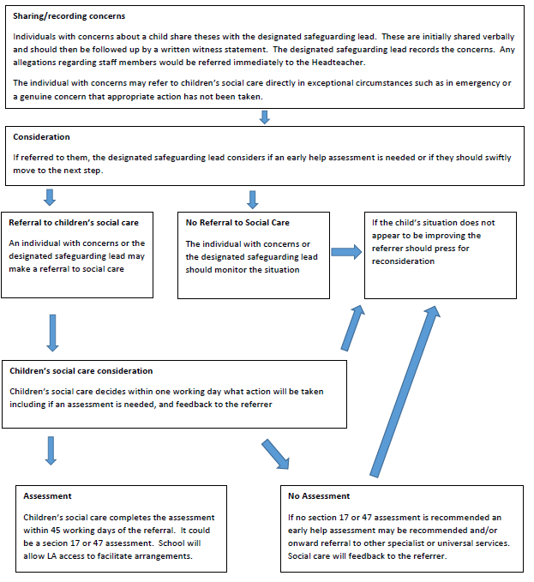
The Year Group Designated Safeguarding Lead will assess any child protection concerns using the following flow chart from ‘Keeping Children Safe in Education.’

If it is decided that a referral is necessary, the Year Group Safeguarding Lead or another designated member of staff will immediately refer cases of suspected abuse or allegation to the Multi-Agency Safeguarding Hub (MASH team) on tel: 0161 770 3790. A telephone referral should be followed by a written record of the referral which will be emailed to the MASH team (using the LSCB multi-agency referral form) as soon as possible and within the school day.
If students are from out of borough the relevant Social Services Safeguarding Team will be contacted.

Sharing information with parents
The school will always undertake to share information with parents/carers where there is an intention to refer a child to statutory services unless to do so could place the child/ young person at greater risk or harm or impede an investigation by statutory services. (See LSCB Guide to ‘Making a Child Protection Referral’)

What to do if a student talks to you about abuse
It should be recognised that a child or young person may seek you out to share information about abuse or neglect, or talk spontaneously individually or in group when you are present. In these situations you should:
- Listen carefully to the student; do not directly question them.
- Allow the student the time to give an account; do not stop a student from recalling events.
- Make an accurate record of concerns using the school witness statement (see appendix 1)
- Reassure the student that they were right to tell
- Explain that you cannot promise not to speak to others, but will only pass on the information to those who need to know.
- Pass the concern directly to the Year Group Designated Safeguarding lead or available member of the child protection team outlined in this policy.

7. Abuse by children and young people
Members of staff should be aware that children and young people are vulnerable to physical, sexual and emotional bullying by their peers. Any incidents of abuse by children or young people should be taken as seriously as abuse perpetrated by an adult, and reported to the designated safeguarding lead or other nominated designated safeguarding staff immediately.
Staff should be alert to the possibility that a child or young person who has harmed another may also be a victim and therefore have unmet needs themselves. However, the interests of the victim must always be the paramount consideration and staff should be alert to the fact that there is likely to be a risk to children other than the current victim.
A disclosure or allegation of abuse should always be referred to the local authority MASH team for assessment.

8. Record Keeping
Any members of staff receiving a disclosure of abuse or noticing signs or indicators of abuse, must make an accurate record as soon as possible noting what was said or seen, putting the event in context, and saving the date, time and location. All records of concerns or disclosures of abuse should be made using the written witness statement (see appendix 1). This must be signed and will include the action taken.
All safeguarding records are kept confidentially and securely on the confidential drive. They are kept separate from pupil records, with a chronology sheet.
An indication of further record keeping is marked on pupil records.
If a pupil transfers from the school those files will be copied and forwarded within five working days to the pupil’s new school marked confidential and for the attention of the receiving school’s designated safeguarding lead person.

9. Opportunities to teach safeguarding

As part of providing a broad and balanced curriculum we teach all students about safeguarding. This is done through a range of subjects including Wellbeing, SRE and ICT. This includes a teaching students about responsible and safe use of the internet and social media. It also includes guidance and support on developing healthy relationships.

10. Training and support
The Head teacher and all other staff who work with children will undertake appropriate child protection awareness training to equip them to carry out their responsibilities for child protection effectively, that is kept up to date by refresher training at ‘regular’ intervals as set out in “Keeping Children Safe in Education” 2015.
The school will ensure that the designated persons undertake refresher safeguarding training every two years to keep knowledge and skills up to date.
All staff (including governors) will receive child protection/safeguarding training when first appointed as part of their induction.
We recognise that staff working in school who may have become involved with a child who has suffered harm or appears likely to suffer harm may find the situation upsetting. We will support such staff by providing an opportunity to talk through their anxieties with the Designated Person and to seek further support if required.

11. Allegations against a member of staff
There is an LSCB procedure for investigating allegations of professional abuse. Issues of concerns should be reported to the Headteacher or the next most senior member of staff who should contact the Local Authority Designated Officer (LADO) TEL:0161 770 8870. In the event of an allegation of abuse being made against the Headteacher, allegations should be reported directly to the Local Authority.
All staff should be aware of their duty to raise concerns about the attitude or actions of colleagues. See the school’s whistle blowing policy.

11. Safer working practice
We understand that staff should have access to advice on the boundaries of appropriate behaviour. The document “Guidance for Safer Working Practice for Adults who work with Children and Young People” (DCSF 2009) provides advice on this and circumstances which should be avoided in order to limit complaints against staff of abuse, and/or allegations of physical or sexual abuse. These matters are referred to in the staff handbook.
This school is committed to safer recruitment and the suitability of all staff at the school. The Head teacher and a Governor will undertake approved safer recruitment training in line with statutory requirements.
School ensures that there is safe practice followed in checking the suitability of staff to work at the school. All school staff have undertaken an enhanced DBS check.
School ensures that visitors or contractors who visit the school premises are appropriately ‘risk assessed’. The identity of visitors/contractors are checked on arrival. School seeks assurances from employers that visitors/contractors have undergone a DBS check where appropriate, and for those for whom a DBS check has not been undertaken, are supervised at all times if they are likely to come into contact with children or young people.

Appendix 1:

Saddleworth School: Safeguarding referral form

N.B. Ensure that you have reported your concerns in person to a member of the safeguarding team before completing this form.

Name of person making referral:
Date/Time:
Name of Pupil:
D.O.B.
Form:
What is the nature of your concern?
- A disclosure made about a student (please ensure PART B is also completed)
- Physical, sexual, emotional abuse or neglect.
- Evidence of impairment of health or development.
- Evidence of ill treatment?
- Why are you reporting this concern now?
- Have you had any previous concerns about this pupil? If so, what, when, what action?
Detail:

If your referral involves a disclosure about a child please also complete PART B
Reported in person to: | Date/Time:
Part B: A Disclosure made about a child
Name of person making the disclosure
WHO is said to be involved?
WHAT is said to have happened/be happening?
WHERE is this said to have happened/be happening?
WHEN is this said to have happened/be happening i.e. duration, most recent occasion etc?
WHO else may have witnessed what happened?
HOW and where is the pupil now?
Any further information disclosed?
Part C: Action taken (To be completed by the safeguarding team)
Staff member dealing with referral:
Brief Summary of action taken:

Appendix 2: Social Care and Police Contact Numbers

Police:

Emergency – 999
Non-Emergency – 101

Social Care Multi-Agency Hubs:

Oldham - 0161 770 3790/ 3791 (Out of hours - 0161 770 6936)
Tameside - 0161 342 4101 (Out of hours - 0161 342 2222)

Appendix 3 – Extracts from Department Of Education publication ‘what to do if you’re worried a child is being abused: advice for practitioners’ March 2015

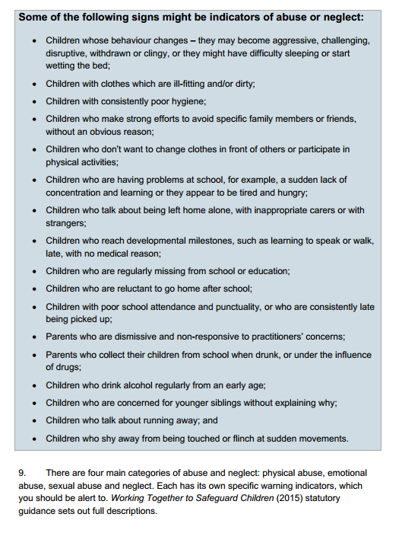

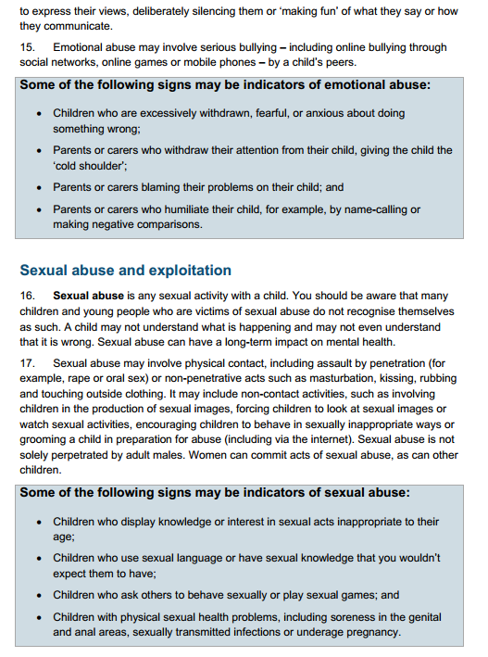

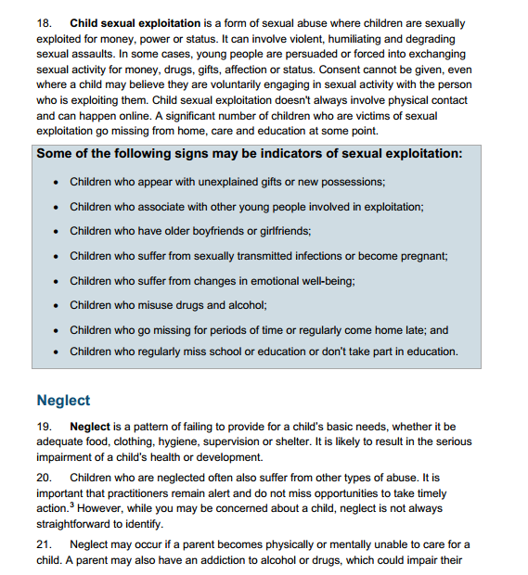

Appendix 3

https://www.gov.uk/government/uploads/system/uploads/attachment_data/file/380125/MultiAgencyPracticeGuidelinesNov14.pdf
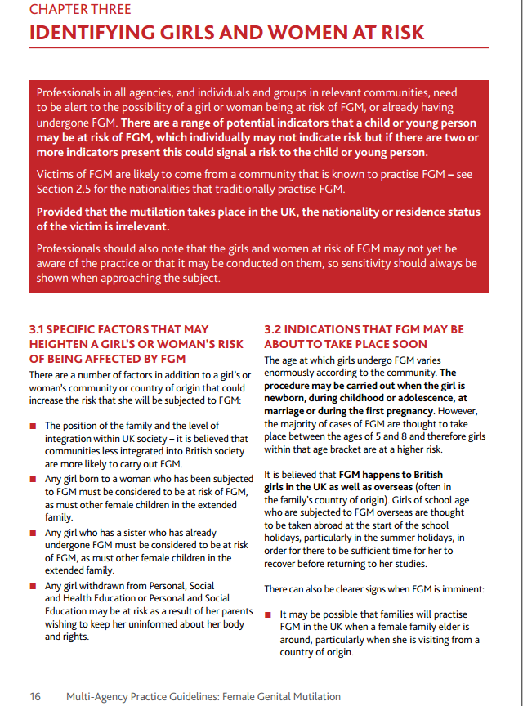
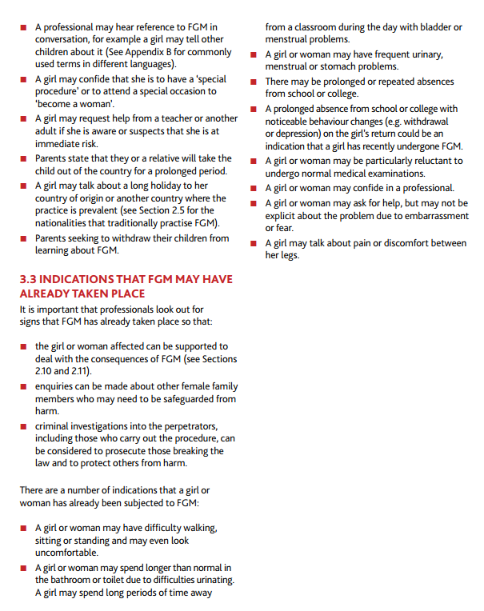

Appendix 4

Child Sexual Exploitation Warning signs that all staff and students should be mindful of:-
There is no stereotypical victim of exploitation, but these warning signs are an indication that a child may be being exploited:
- Regularly missing from home or school and staying out all night
- Change in behaviour – becoming aggressive and disruptive or quiet and withdrawn
- Unexplained gifts or new possessions such as clothes, jewellery, mobile phones or money that can’t be accounted for
- A significantly older ‘boyfriend’ or ‘friend’ or lots of new friends
- Spending excessive amounts of time online or on their mobile and becoming increasingly secretive about this activity
- Student involvement in criminal behaviour or increased offending
- Sexual health problems
- Changes in physical appearance
Taken from ‘It’s not okay’ 2014

