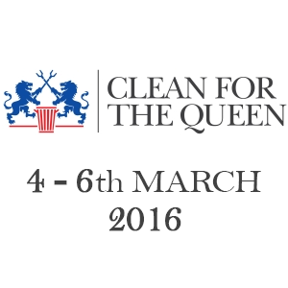
Ref: CMO/ARE
3rd March 2015
Dear Parent / Carer,
As part of their Community Contribution the year 7 students are getting involved in this National Campaign. Clean for the Queen is a campaign to clear up Britain in time for Her Majesty the Queen’s 90th birthday, which will be officially celebrated in June 2016.
Tomorrow each form will donate 1 lesson (55 minutes) to help make a difference. By the end of the day we would have contributed as a school just over 250 hours to making our local community a better place.
All students will attend a presentation in advance of their involvement about the programme and in which we will discuss our expectations in terms of behaviour out of school and remaining safe (this will include items that we would not expect them to pick up if seen). To help keep them safe they will also be provided with gloves to ensure that they do not come into direct contact with the items of litter.
Accompanied by their teacher, they will be designated a local area in close proximity to the school to work on as a class. We are hoping the weather is kind to us and allows this to take place. It is advisable that students do bring a warm coat to school and they will be permitted to change into more appropriate footwear for their clean if they wish.
I hope you are able to support the programme by offering your consent. If there are any issues you would like to discuss or any further information you would like please get in touch on c.mcmurdo@saddleworthschool.org
Many thanks in anticipation
Claire McMurdo
Assistant Headteacher

