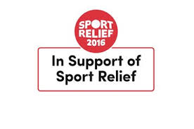
Ref: MMN/ARE
18th March 2016
Dear Parent / Carer,
This year we are really excited to be raising money for Sport Relief 2016.
As one of the UK’s biggest fundraising events, Sport Relief brings the entire nation together to get active, raise cash and change lives.
SADDLEWORTH SCHOOL has decided once again to get involved and help raise money for this incredible cause, after the tremendous efforts the school made in 2014.
To do our bit and raise money this year we will be:
Asking pupils and staff to run/jog/walk as many miles during ONE DAY to try and achieve the equivalent distance of SADDLEWORTH TO ATHENS (HOME OF THE OLYMPICS) WHICh is a grand total of 1635 miles (or about 13,100 laps!!??).
ON THURSDAY 24TH MARCH between 8.00am & 5.00pm on the school astro-turf.
ALL STAFF AND PUPILS are being asked to WEAR SPORTS CLOTHING AS it will be a non-uniform day.
all ks3 pe lessons will focus on the run/walk during the day whilst staff + ks4 can support the cause in other lessons/lunchtime/after school.
We would like parents to support this venture by enabling pupils to donate a minimum of £1 for wearing non-uniform/sportswear on the day, which will go to the Sport Relief Charity.
And, the best bit is, the money raised by the public is spent by Comic Relief to help people living incredibly tough lives, both at home in the UK and across the world's poorest countries. To find out more about Sport Relief visit sportrelief.com/schools.
We really appreciate your support and hope that you’ll support the fun helping our school raise lots of money for Sport Relief.
Yours sincerely,

PE Department

